Order Of Service

Singing: Psalm 23—CW page 72

Reading: Psalm 132

Opening Hymn: TLH 128

Reading: Romans 13:1-7

Request Hymn: CW Supplement 749

Reading: Matthew 22:23-33

Sermon Hymn: TLH 134

Sermon Text: Luke 4:22-32

Rejection And Hatred

Prayer

The Apostles’ Creed, TLH page 12

Holy Communion

The Lord's Prayer

The Blessing

Closing Hymn: TLH 135

* * * * * * * * * * *

Bible Study: Lambs: Octopus
Sheep: Proverbs 28:1-5
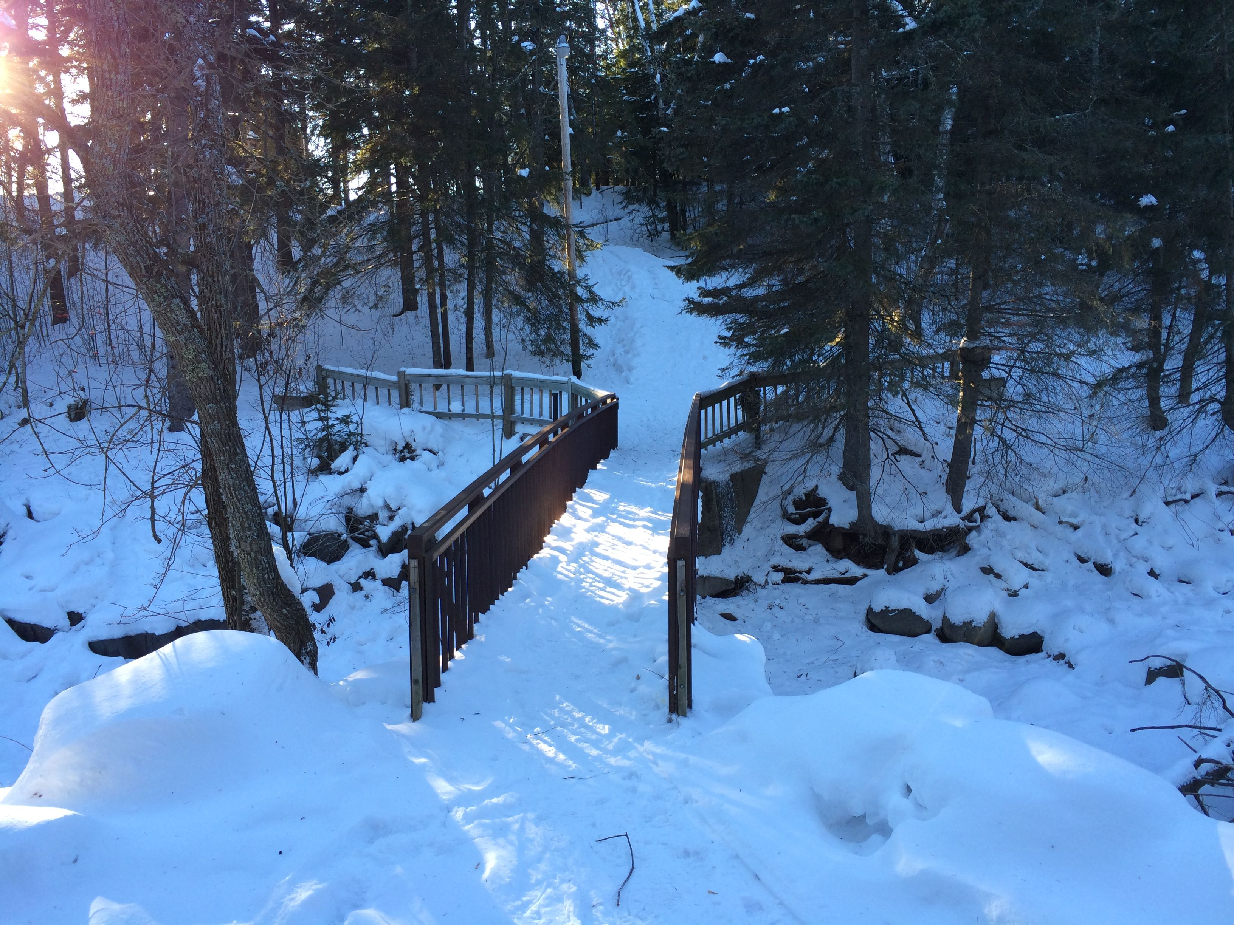

Scenic Duluth, MN

Water
Of
Life

31 January 2021

W A T E R O F L I F E

Independent Christian Church—Conservative Lutheran Doctrine

Worship Service: 9:30 a.m. Bible Study: 10:45 a.m.

Larry Cooper, Pastor E-Mail address:
111 N. Ridge Road lcooper@wateroflife.cc
Coon Valley, WI 54623 Web Site:
www.wateroflife.cc

* * * * * * * * * * * * * * * * * * * * * * * * * * *

Sermon Text: Luke 4:22-32

Rejection And Hatred

* * * * * * * * * * * * * * * * * * * * * * * * * * *

22 And all bare him witness, and wondered at the gracious words which proceeded out of his mouth. And they said, Is not this Joseph's son?
23 And he said unto them, Ye will surely say unto me this proverb, Physician, heal thyself: whatsoever we have heard done in Capernaum, do also here in thy country.
24 And he said, Verily I say unto you, No prophet is accepted in his own country.
25 But I tell you of a truth, many widows were in Israel in the days of Elias, when the heaven was shut up three years and six months, when great famine was throughout all the land;
26 But unto none of them was Elias sent, save unto Sarepta, a city of Sidon, unto a woman that was a widow.
27 And many lepers were in Israel in the time of Eliseus the prophet; and none of them was cleansed, saving Naaman the Syrian.
28 And all they in the synagogue, when they heard these things, were filled with wrath,
29 And rose up, and thrust him out of the city, and led him unto the brow of the hill whereon their city was built, that they might cast him down headlong.
30 But he passing through the midst of them went his way,
31 And came down to Capernaum, a city of Galilee, and taught them on the sabbath days.



